1. **HashSet**:
   1. Under the hood, HashSet is going to use array and hash-fun.
2. 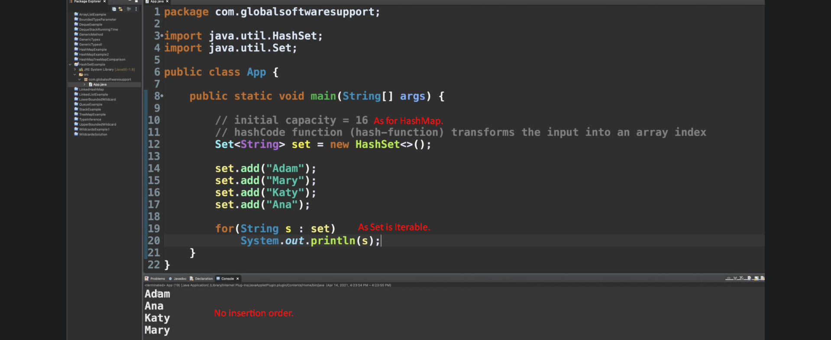
3. 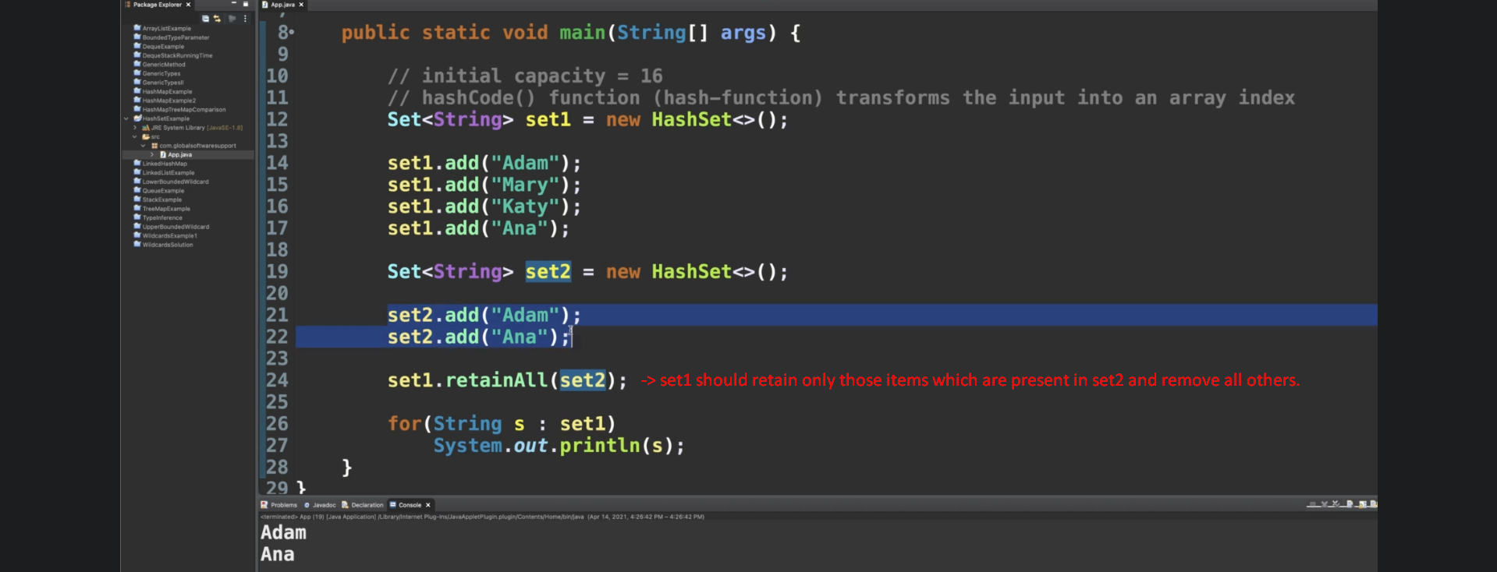
4. 